A COMPREHENSIVE ANALYSIS OF FINANCIAL PERFORMANCE:INSIGHTS FROM A LEADING BANKS Project based experiential learning program

***INTRODUCTION:***

The banking industry world-wide is being transformd. The global forces for change include technological innovation; the deregulation of financial services at the national level and opening-up to international competition; and-equally important-changes in corporate behavior, such as growing disintermediation and increased emphasis on shareholder value. In addition, recent banking crises in Asia and Latin America have accentuated these pressures. The banking industries in central Europe and Latin America have also been transformed as a result of privatizations of state-owned banks that had dominated their banking systems in the past. In this project we are trying to analysis the bank related data and able to extract some insights from the data using Business Intelligence tools. To Extract the Insights from the data and put the data in the form of visualizations, Dashboards and Story wae employed Tableau tool.

***TABLEAU:***

Tableau was found in 2003 to enrich the the business but I become one the business strategy. As the market leading choice for modern business platform makes it easier for the people to explore and manage data and faster to discover and share insights that can business and the world.

***DEFINE PROBLEM:***

A business problem can be defined as any hurdle, situation, or variation that leads toj a difference between the desired objectives and accomplished results. Some problems present themeselves, while others require in-depth analysis of the organization. We can creat the report to identify the area for improvement and get the idea of developing the affected.

The business requirements for analyzing the performance and efficiency of banks in world include identifying KPIs, comparing performance across different countries and states, identifying patterns and trends over time, identifying affecting facors, creating interaacctive dahoboards and reports creating forecasting model for

future performance through data visualization techniques.

The banks would involve researching and reviewing previous studies, articles, and reports on the topic. To develop strategies for improving the bank’s performance, such as by reducing costs, increasing revenue, or improving risk management practices.

# *DATA COLLECTION & EXTRACTION FROM DATABASE:*

# Data collection is the collection data from various source and measuring informatiom . Here the data contain all the type of information in the form of comma separated values. Data collection is the process of gathering and measuring information on variables o interest, in an established systematic fashion that enables one to answer stated research questions, test hypotheses, evaluate outcomes and generate insights from the data. The performed data in database and connect the database to tableau.

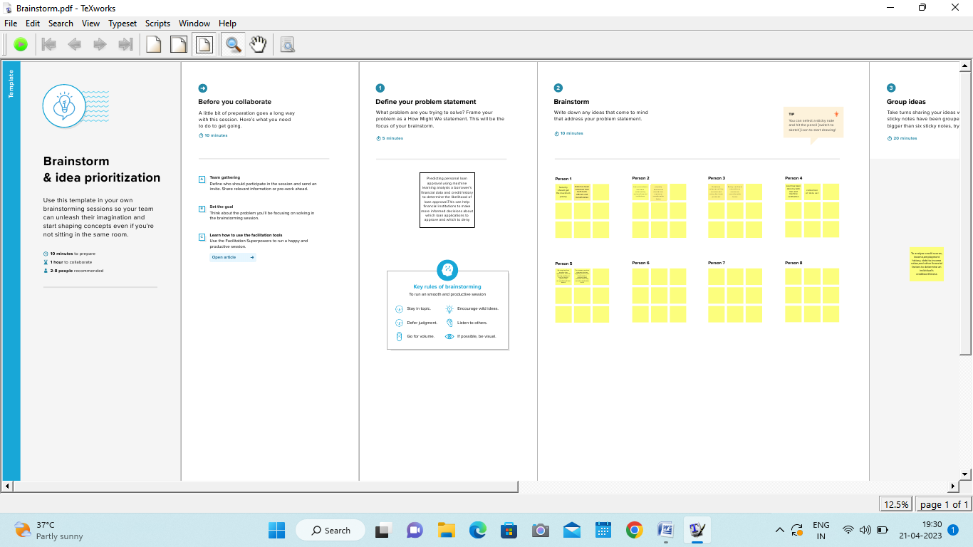

***DATA PREPARATION:***

**Preparing the data for visualization involves cleaning the data to remove irrelevant or missing data, transforming the data into a format that can be easily visualized, exploring the data to identify patterns and trends, filtering the data to focus on specific subsets of data, preparing the data for visualization software, and ensuring the data is accurate and complete.**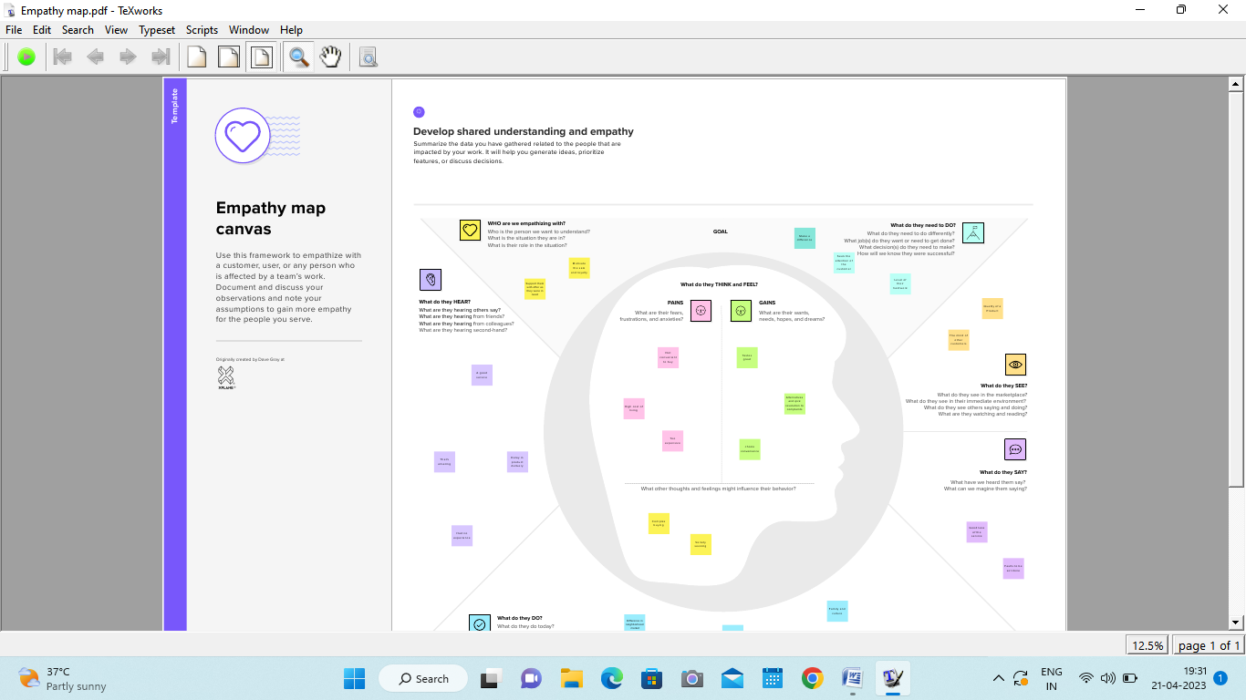

# *DATA VISUALIZATION:*

Data visualization in the process of creating graphical representations of data to help people understand and explore the information. Data visualization is the representation of data through use of common graphics, such as charts, plots, infographics, and even animations. These visual displays of information communicate complex data relationships and data-driven insights in a way that is easy to understand. data visualization isn’t limited to performance dashboards. For example, while [text mining](https://www.ibm.com/in-en/topics/text-mining) an analyst may use a word cloud to to capture key concepts, trends, and hidden relationships within this unstructured data. Alternatively, they may utilize a graph structure to illustrate relationships between entities in a knowledge graph. There are a number of ways to represent different types of data, and it’s important to remember that it is a skillset that should extend beyond your core analytics team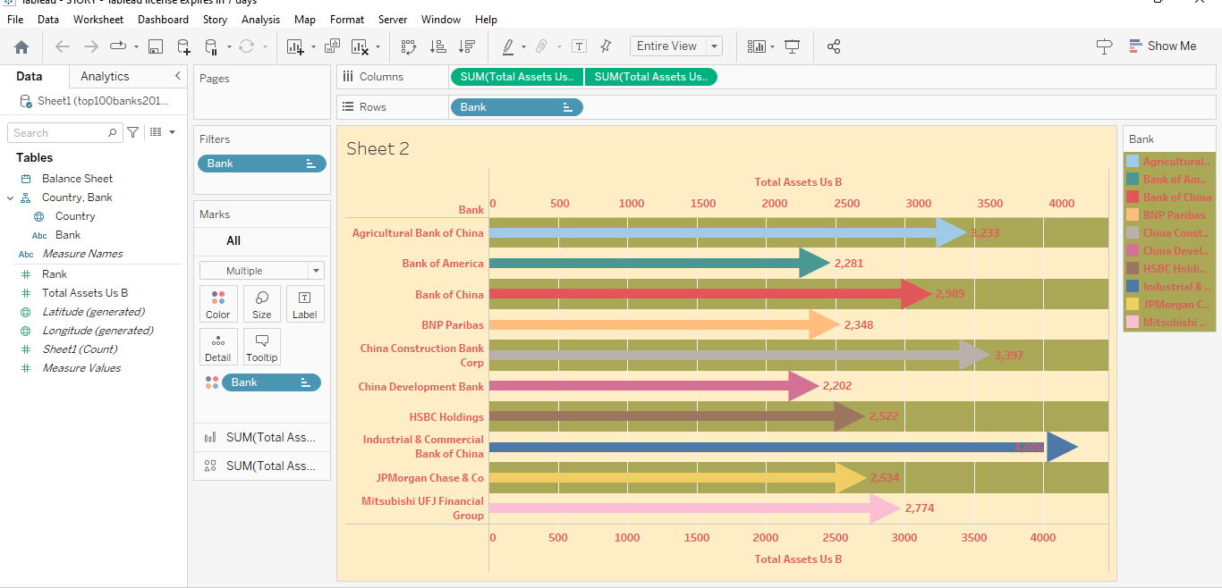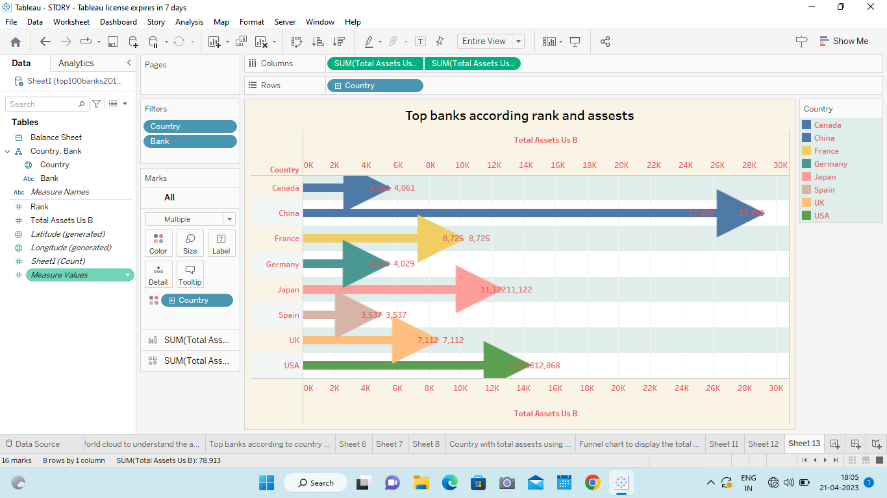 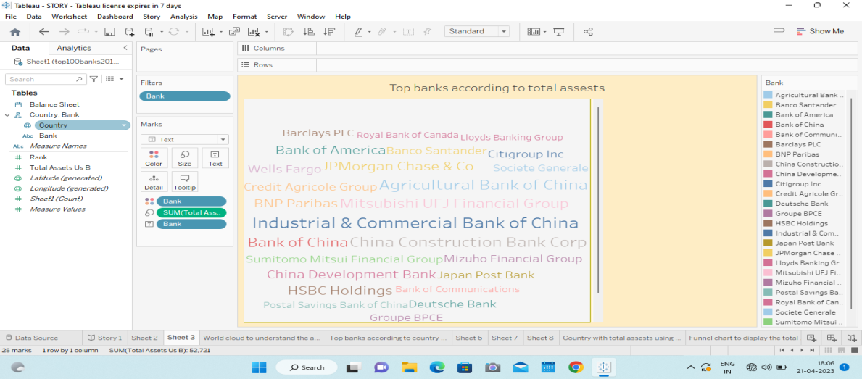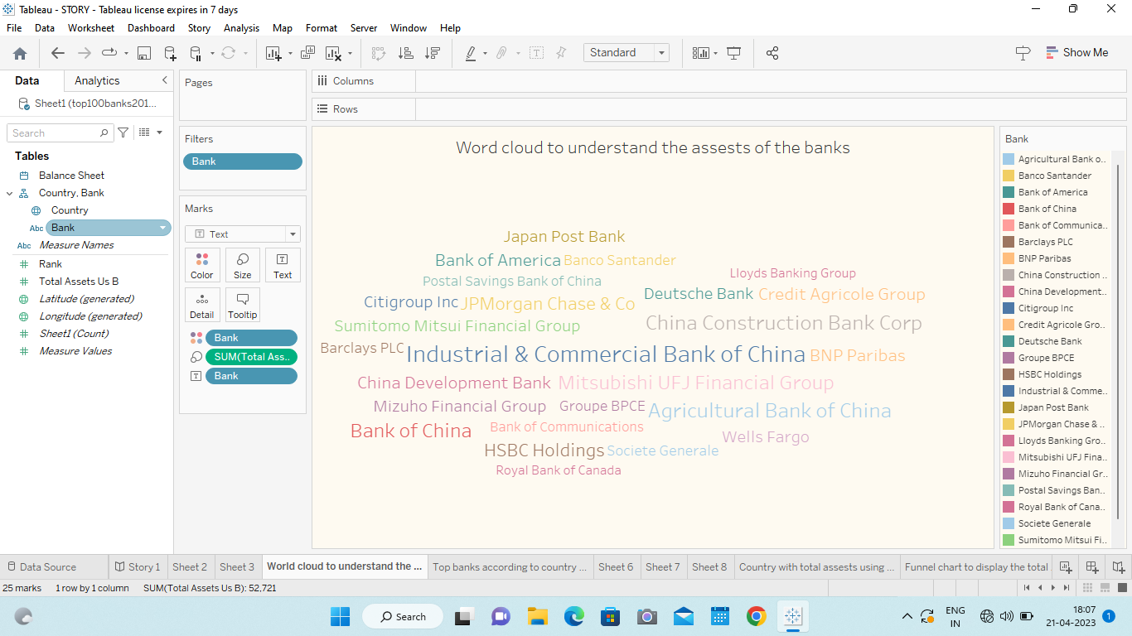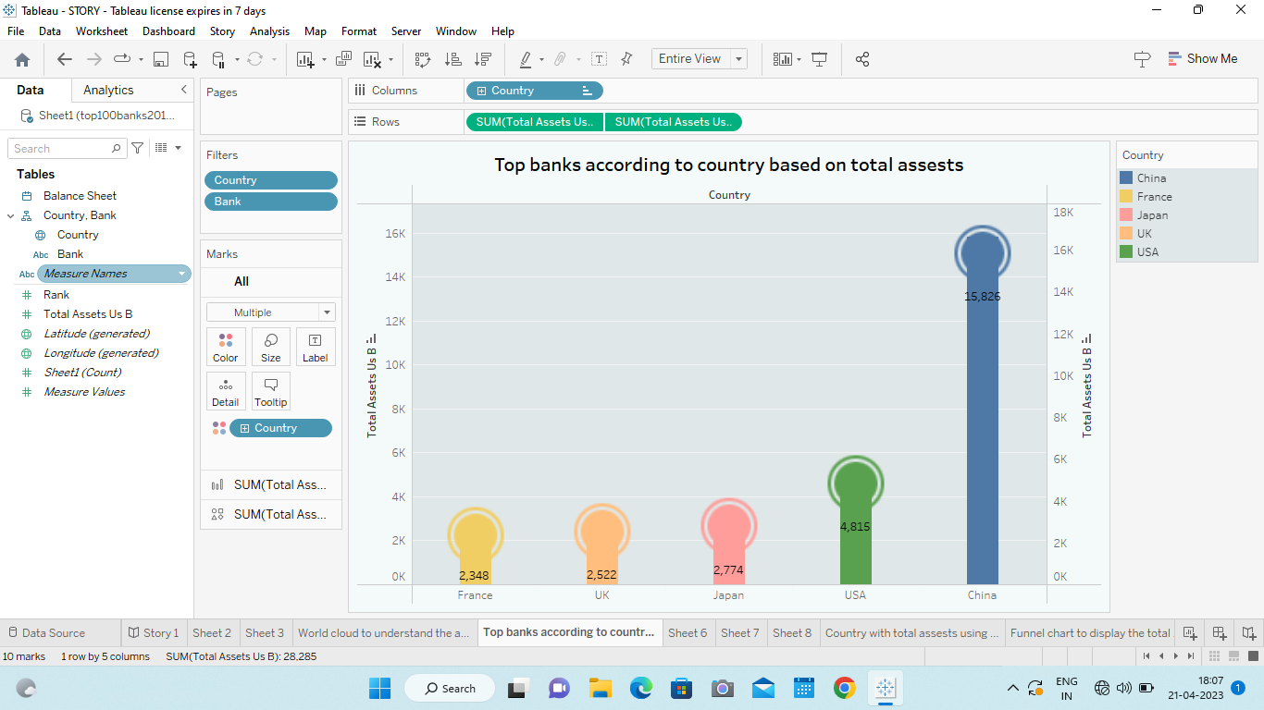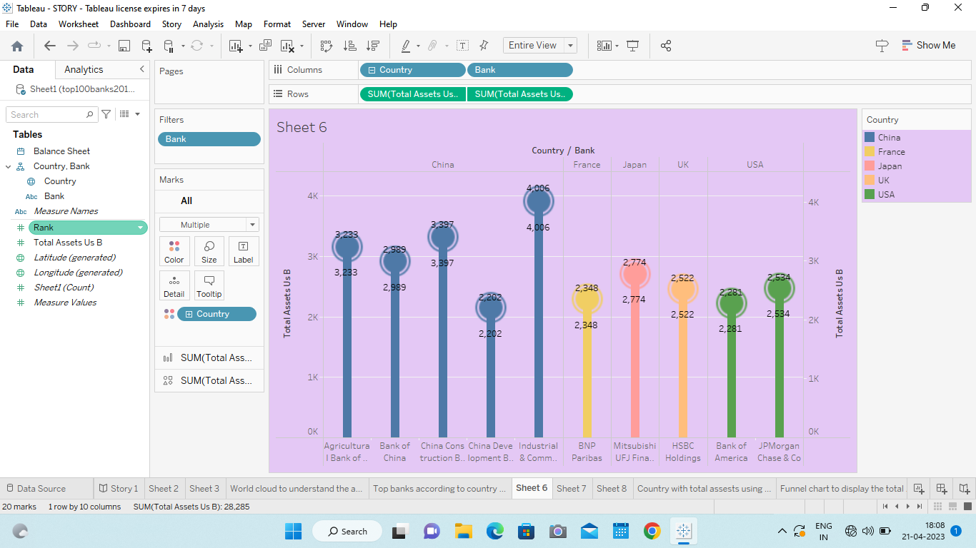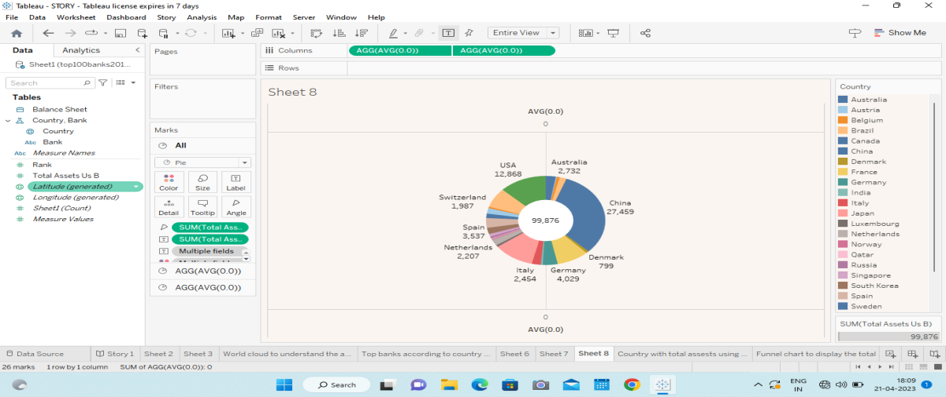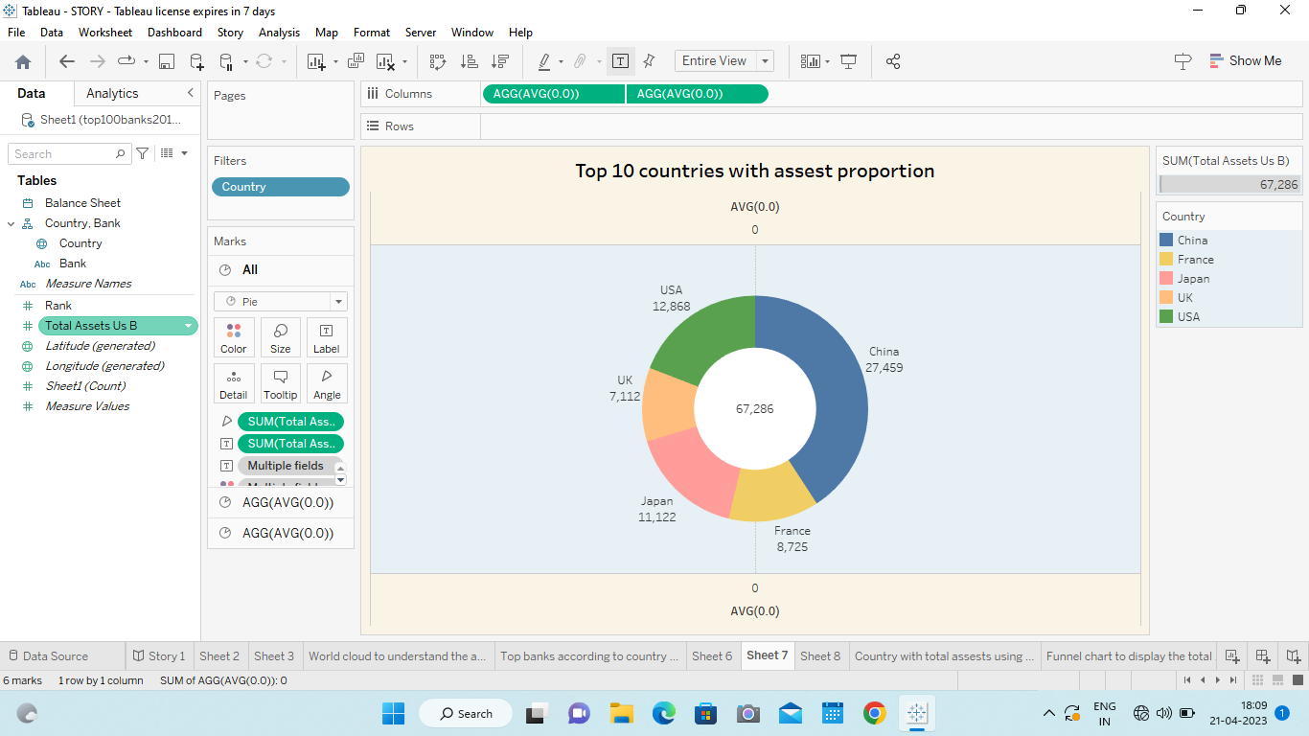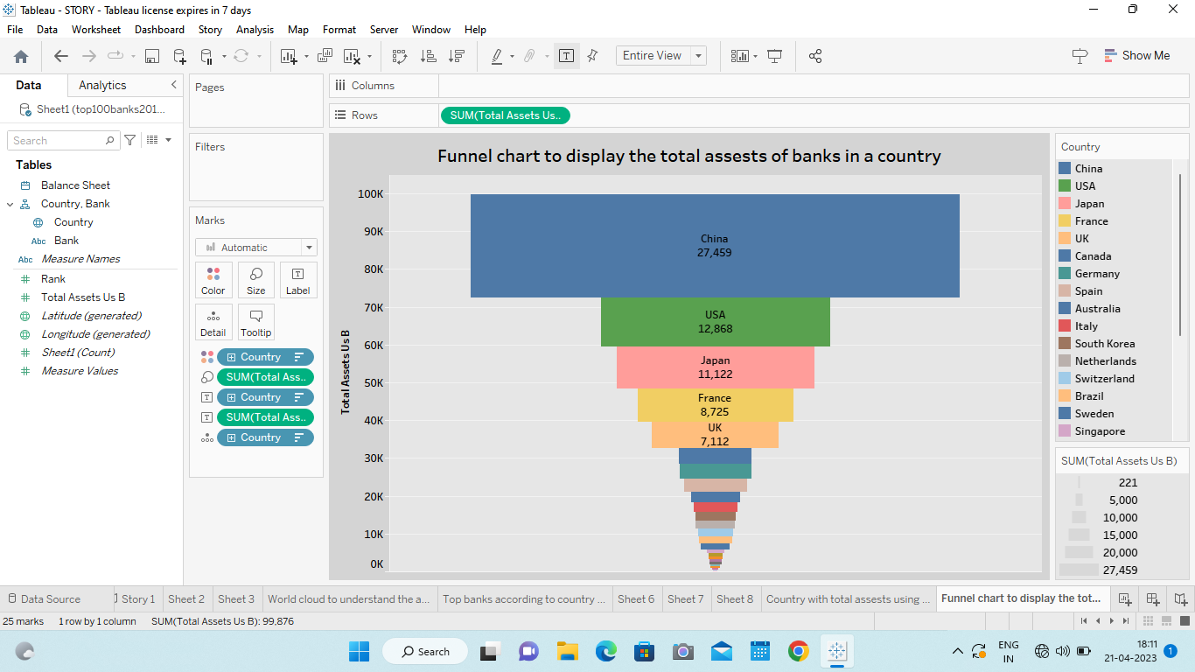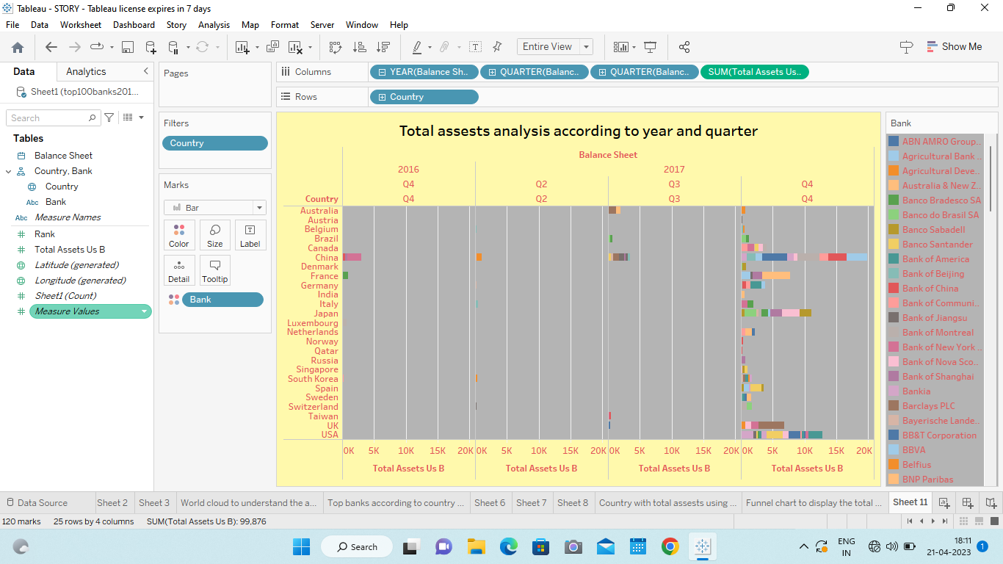

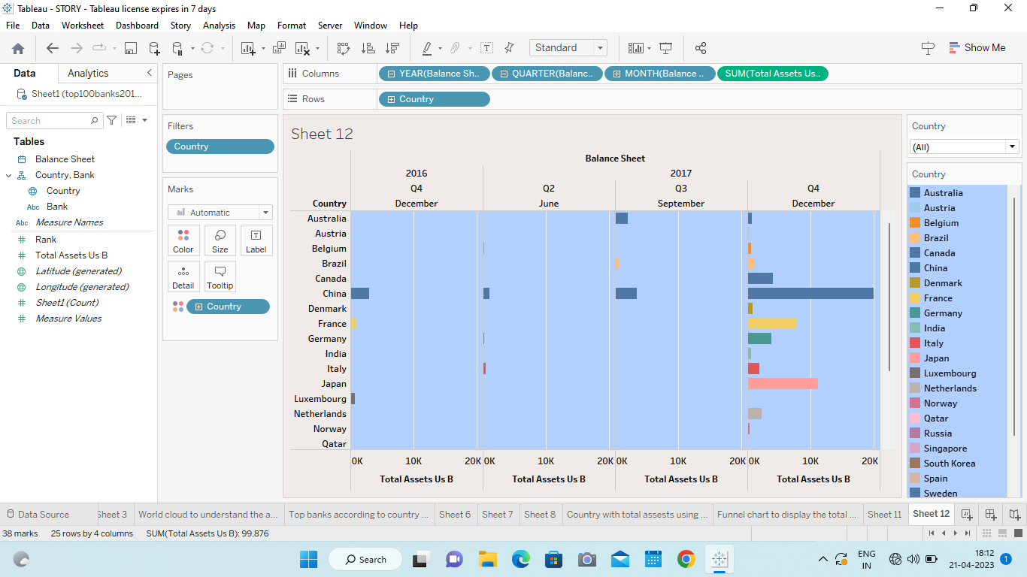

# DASHBOARD

 a **dashboard** is a type of [graphical user interface](https://en.wikipedia.org/wiki/Graphical_user_interface) which often provides at-a-glance views of [key performance indicators](https://en.wikipedia.org/wiki/Key_performance_indicators) (KPIs) relevant to a particular objective or business process. Dashboards can be used in the variety of settings such as business finance manufacturing and healthcare. The “dashboard” is often accessible by a web browser and is usually linked to regularly updating data sources Initially dashboards were used for monitoring purposes, now with the advancement of technology, dashboards are being used for more analytical purposes. .for example: The [COVID-19 pandemic](https://en.wikipedia.org/wiki/COVID-19_pandemic) of 2020 brought other dashboards to the fore, with the [Johns Hopkins](https://en.wikipedia.org/wiki/Johns_Hopkins_University) coronavirus tracker[[3]](https://en.wikipedia.org/wiki/Dashboard_(business)#cite_note-:1-3) and the UK government coronavirus tracker. Bulding and formating a dashboard using size,objects,view and filters. Benefits of using digital dashboards include: Visual presentation of performance [measures](https://en.wiktionary.org/wiki/measures) and etc. Dashboards are also used in accounting decision making settings. The data can help prove a change is efficient or inefficient and therefore help with improving systems throughout a n organisation.

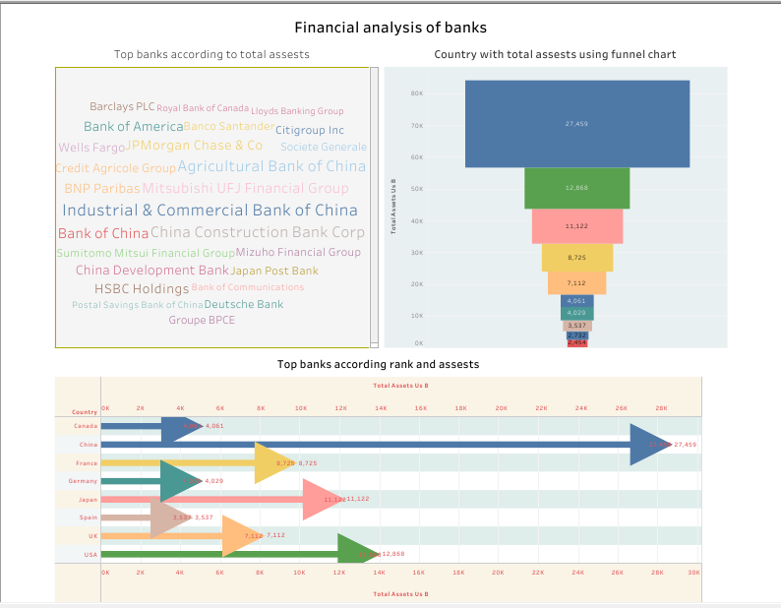

STORY

story is a way of presenting data and analysis **in** a narrative format,intending to make the information more engaging data.A data story typically includes a clear introduction that sets the stage and explains the context for the A data.A Conclusion that summarizes the key findingsband highlights their implications.Dta stories can be told using a variety of mediums,such as reports,presentation,interactive visualizations,and videos.The number of scenes in a storyboard for a data visualization analysis of the performance of banks will depend on the complexity of the analysis and the specific insights that are trying to be conveyed.A storyboard is a visual representation of the data analysis process.

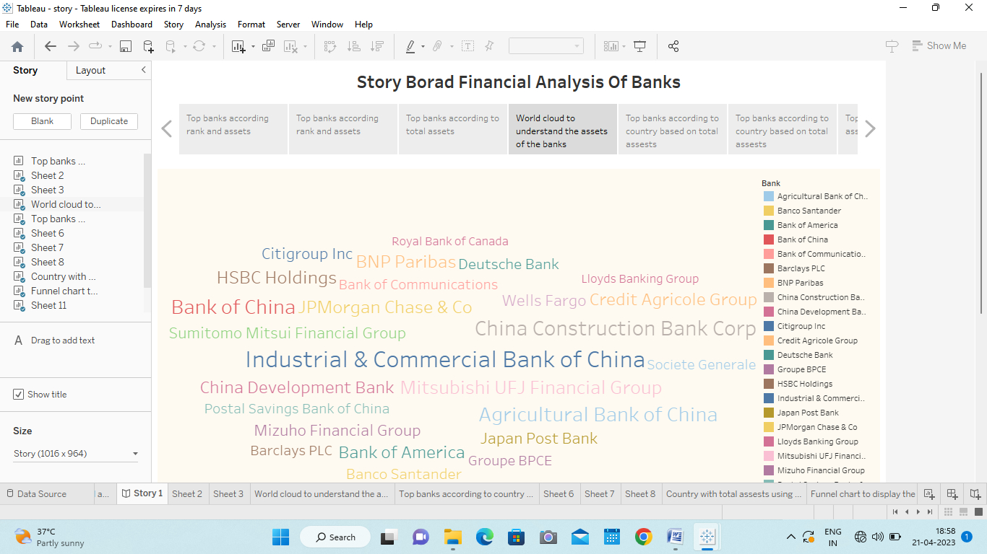

PERFORMANCE TESTING

# Performance testing is a MySQL feature for monitoring MySQL Server events and query execution. Stress testing,sometimes referred to as load testing,involves running many statements from various connections or threads against a SQL server database. Performance testing is a testing measure that evaluates the speed, responsiveness and stability of a computer, network, software program or device under a workload.The amount of data that is rendered to a database depends on the size of the dataset and the capacity of the database store and retrieve data.

WEB INTEGRATION

A website integration is when your website sends or receives information from another application, system, or website. Website integrations are useful when you want to connect data from different sources. Website integration is when your website sends or receives information from another website or application.Publishing helps us to track and moniter key perormance metrics and to communicate results and progress.help a publisher stay informed,make better decisions and communicate their performance.

PROJECT DEMONSTRATION AND DOCUMENTATION

In this project based on the financial analysis of banks can have a significant social impact by identifing areas.The ultimate goal is to gain insights and improve performance through data visualisation techineques. It involves economics scenarios to evaluate a banks ability to withstand financial stocks. The project team is expected to follow certain procedures, specifications, and guidelines for such documents, including a project plan and schedule.Documentation can be consulted by team members when they want to find out the status of the project.

ADVANTAGE OF THIS PROJECT

1. Strong financial position: Leading banks are typically well-capitalized and have a strong financial position due to their large asset base, which enables them to weather economic downturns and market volatility.

2. Diversified revenue streams: Most leading banks have diverse revenue streams, including interest income, fee-based income, and FICC (fixed income, currencies, and commodities) trading, which enables them to balance out revenue volatility.

3. Established brand and reputation: Leading banks typically have a long-standing reputation and well-established brand which instills trust and confidence in their clients, stakeholders and the market.

4. Access to capital markets: Leading banks, due to their strong brand and reputation, typically have access to both debt and equity capital markets, which provides them with the financial flexibility to grow and expand their businesses.

DISADVANTAGE OF THIS PROJECT

1. Complexity: With their large size and diversified operations, leading banks have complex organizational structures, which can lead to inefficiencies, lower productivity, and increased regulatory scrutiny.

2. Systemic risk: Because of their size and interconnectedness, leading banks pose a systemic risk to the financial system, which can have far-reaching consequences in the event of a crisis.

3. Regulatory burden: Leading banks are subject to strict regulation and oversight, which can increase operational and compliance costs, reduce profitability, and limit innovation.

4. Reputation risk: In the event of a scandal, leading banks can suffer severe reputational damage, which can result in loss of customers, regulatory penalties, and legal liability.

# *CONCLUSION*

From this project we can understand about tableau and using this tableau can able to bring the revolution in business world. Leading banks have both advantages and disadvantages when it comes to their financial performance. While they have strong financial positions, diversified revenue streams, established brands, and access to capital markets, they also face complexity, systemic risk, regulatory burden, and reputation risk.

# 